PHYSICAL ACTIVITY READINESS QUESTIONNAIRE (PAR-Q) 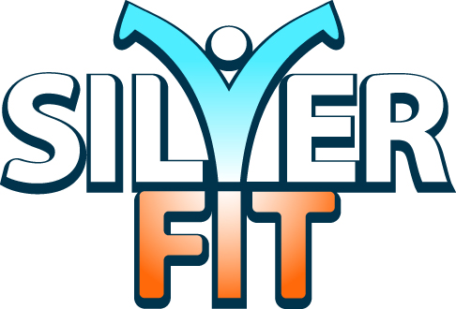

Name ………………………………………………………………………………………………………………… Venue ……………………………………

Address…………………………………………………………………………………………………………… Tel no …………………………………………

Date of Birth …………………………………… Email ……………………………………………………………………………………………………

Emergency contact …………………………………………………………………………………………………………………………………………………

Being active is safe for most people. However, some people should check with their doctor before starting to become MORE physically active. If you are planning to undertake much more physical activity than you are used to, please let one of our Silverfit session leaders know. (The following medical history information will be stored confidentially)

Have you ever suffered from heart trouble? YES NO
Are you presently taking any medication which may affect your physical abilities? YES NO
Do you suffer from chest pains? YES NO
Do you ever have spells of dizziness or feel faint? YES NO
Have you ever had either high or low blood pressure, and/or high cholesterol YES NO
level? If YES please indicate which
…………………………………………………………………………………………………………………………
Have you ever had asthma, chronic bronchitis, chest pain brought about by physical activity or other chest ailments? YES NO
Do you suffer from back pain or any orthopaedic problem? YES NO
If YES please indicate which…………………………………………………………………………
Do you suffer from severe headaches or migraines? YES NO
Are you recuperating from a recent illness/operation or injury? YES NO
If YES please expand………………………………………………………………………………………
Have you any other medical condition that we should be aware of, and that could be made worse by increased physical activity, eg walking a mile at a slightly elevated pace? YES NO
Do you suffer from depression, anxiety of other mental health condition YES NO
Do you have any allergies we should know of? YES NO
If YES please expand………………………………………………………………………………………

If you answered YES to any of questions 1 to 11, you are advised to seek medical advice/approval before commencing our exercise programme or consult further with your instructor.

I have been informed that if I answer YES to any of questions 1 to 11 of this questionnaire, I should seek medical advice/approval before commencing an exercise programme. If I choose to continue without such advice I do so entirely at my own risk. I have read, fully understood and answered the above questions honestly. I understand that in taking part I have a responsibility for my own, and my fellow participants’ health and safety and that if I think something is dangerous or painful I should stop and let the leader know.

If there is any change in my health of which instructors should be informed, I confirm I will tell either the instructor or a representative of Silverfit
Please Tick here to confirm that you are happy for us to use your data anonymously for Silverfit research ☐

Signed: …………………………………………………………………………………………………………………… Date: …………………………………

